**EE219 Project 5**

**Popularity Prediction on Twitter**

**Winter 2017**

Shubham Mittal - 104774903

Anshita Mehrotra - 904743371  
Swati Arora - 404758379

*Introduction:*

Twitter, today, is a good platform to predict future popularity of a topic or event. We can perform social network analysis, by knowing current and previous tweet activity for a hash-tag (#), we can predict if it became more prominent and trendy in the future and if yes by how much.

In the project, the twitter data used is collected by querying popular hash-tags related to the 2015 Super Bowl. The data is collected starting from 2 weeks before the game to a week after the game. This data is then used to train a regression model and then the model is used for making predictions for other hash-tags. The test data consists of tweets containing a hash-tag in a specified time window, and we have then used our model to predict number of tweets containing the hash-tag posted within one hour immediately following the given time window.

*Part 1:* *Tweet Data Analysis and Statistics*

In this problem, we load calculate some statistics for each hashtag such as average

number of tweets per hour, average number of followers of users posting the tweets,

and average number of retweets.

Every hashtag information is loaded from the corresponding hashtag file into python by reading JSON objects. Each line in the file representing a tweet was parsed to extract

information regarding the corresponding hashtag.

We calculate the metrics using following formulas:

$$Average number of tweets per hour=\frac{Total number of tweets}{Total number of hours}$$

$$Average number of retweets per hour=\frac{Total number of retweets}{Total number of tweets}$$

$$Average number of followers per user =\frac{Total number of followers}{Total number of unique users}$$

**Metrics for each tag is as follows**:

|  |  |  |  |
| --- | --- | --- | --- |
| Hashtag | Average number of tweets per hour | Average number of retweets per hour | Average number of followers per user |
| #gohawks | 193.5555 | 2.01461 | 1544.9697 |
| #gopatriots | 38.4070 | 1.4000 | 1298.8242 |
| #nfl | 279.4217 | 1.5385 | 4289.7466 |
| #patriots | 499.1977 | 1.7828 | 1650.3219 |
| #sb49 | 1420.8780 | 2.5111 | 2235.1636 |
| #superbowl | 1400.5887 | 2.3882 | 3591.6044 |

**Bar graph for each hashtag is as follows**:



Figure 1 : Figure illustrating Number of tweets per hour for gohawks hashtag over the duration of time



Figure 2: Figure illustrating Number of tweets per hour for gopatriots hashtag over the duration of time



Figure 3: Figure illustrating Number of tweets per hour for nfl hashtag over the duration of time



Figure 4 : Figure illustrating number of tweets per hour for patriot’s hashtag over the duration of time



Figure 5 : Figure illustrating number of tweets per hour for sb49 hashtag over the duration of time



Figure 6 : Figure illustrating number of tweets per hour for superbowl hashtag over the duration of time

**Analysis of Statistics:**

|  |  |
| --- | --- |
| Most retweeted Hashtag on an average | #superbowl and #sb49 |
| Most tweeted Hashtag on an average | #superbowl and #sb49 |
| Most followers to users tweeting hashtag | #nfl and #superbowl |

This analysis can also be visualized from Figure 6 (superbowl) , Figure 5 (sb49) and Figure 3(nfl). Figure 5 and Figure 6 show steep rise which is indicative of high activity for that hashtag.

*Part 2: Linear Regression*

In this problem, we make predictions for tweets in the next hour based on the features collected from previous hour tweet. The features on which this linear regression model is build are as follows:

1. Number of tweets
2. Total number of retweets
3. Sum of the number of followers of the users posting the hashtag
4. Maximum number of followers of the users posting the hashtag
5. Time of the day (indicating an hour out of 24 hours)

An hour window approach same as problem I is employed to calculate the features information for any given hour to make predictions for next hour.

We obtained the summarized results after fitting the linear regression model for each hashtag. Summarized reports for each hashtag are as follows:

1. #gohawks

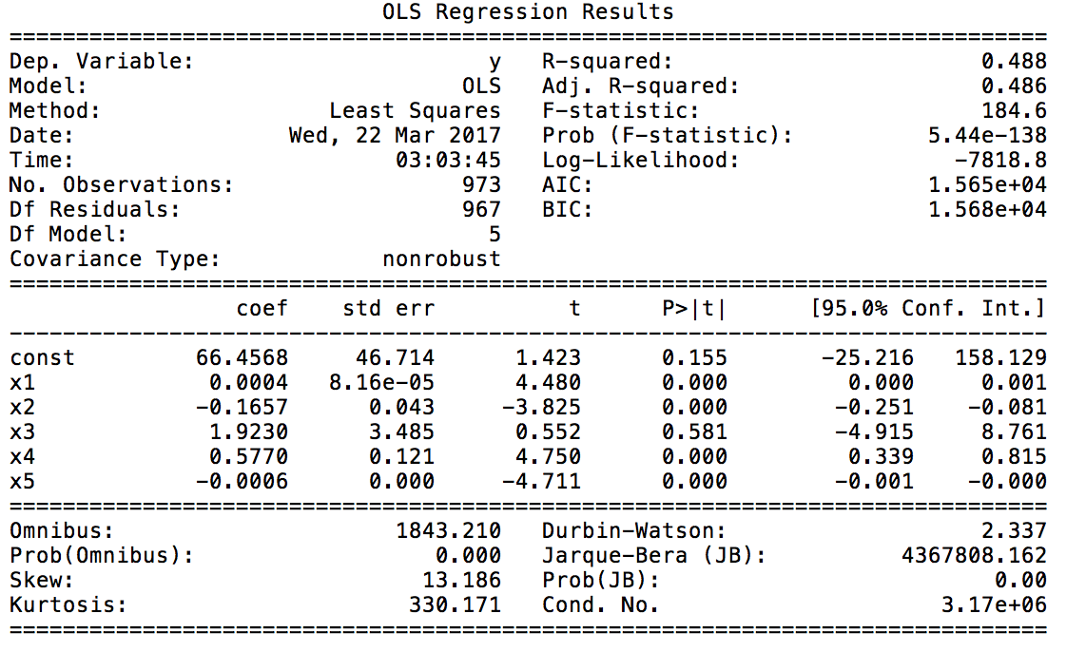

Report 1 : OLS Regression Results for gohawks hashtag. R-squared accuracy can be observed as 0.488 indicating not a good fir to the model for this hashtag.

1. #superbowl

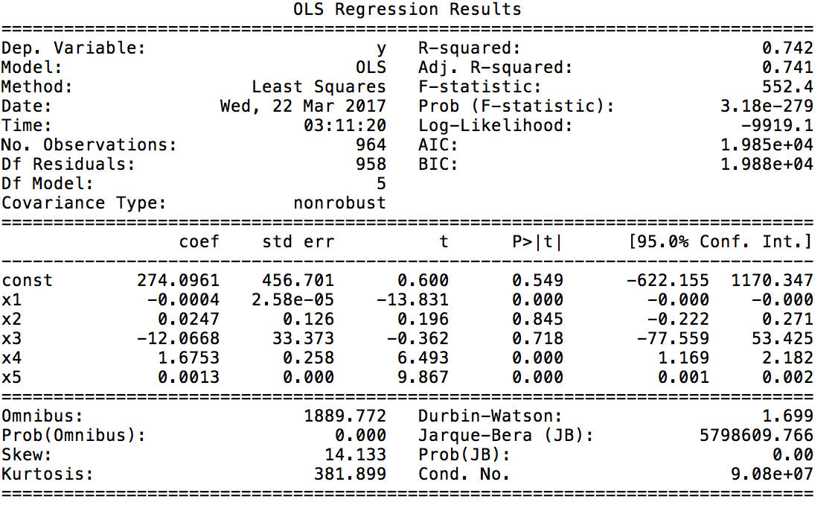

Report 2 : OLS Regression Results for superbowl hashtag. R-squared accuracy can be observed as 0.742 indicating a good fit to the model for this hashtag.

1. #gopatriots

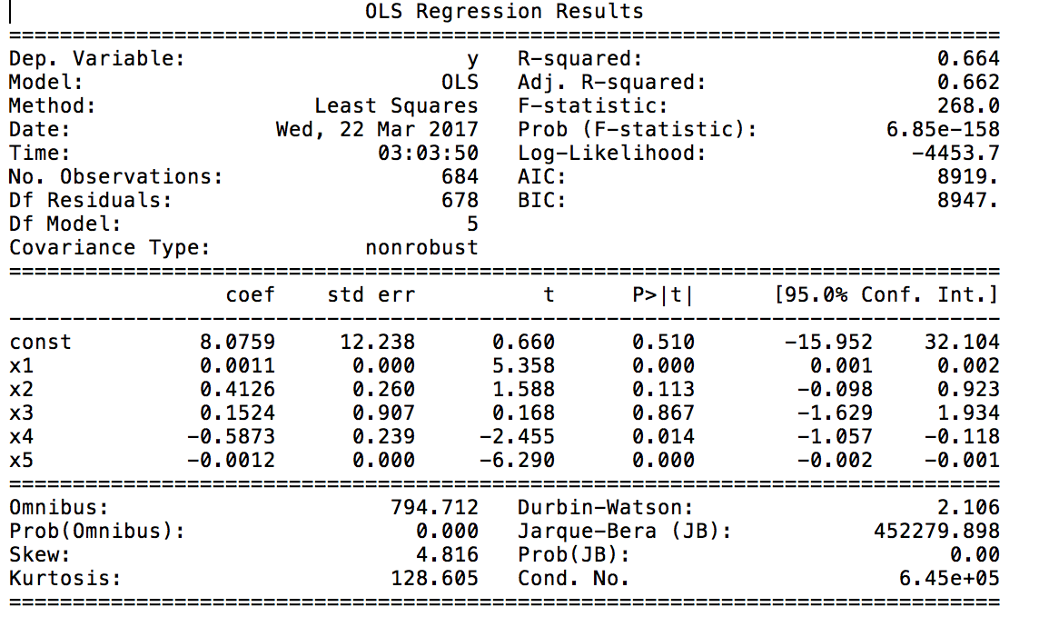

Report 3 : OLS Regression Results for gopatriots hashtag. R-squared accuracy can be observed as 0.664 indicating a decent fit to the model for this hashtag

1. #sb49

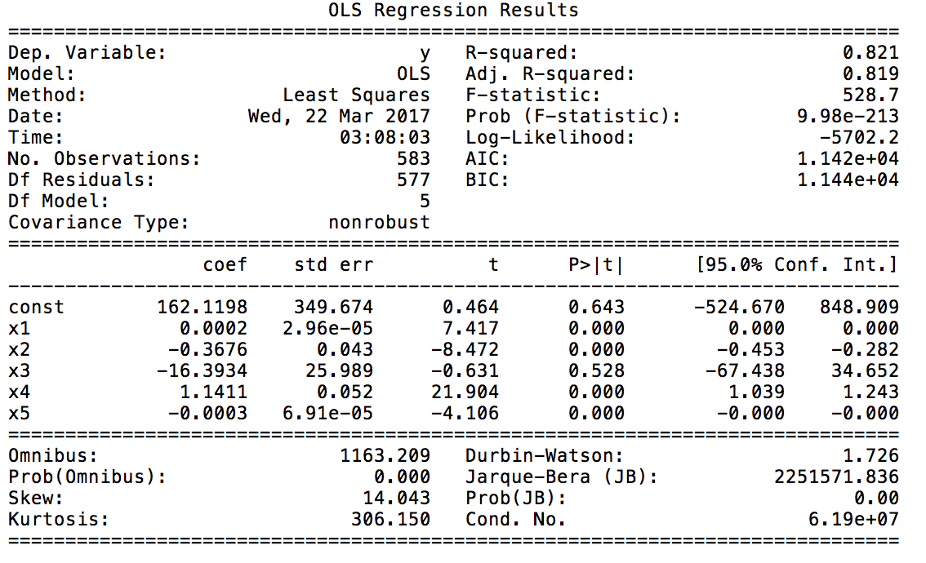

Report 4 : OLS Regression Results for sb49 hashtag. R-squared accuracy can be observed as 0.821 indicating a very good fit to the model for this hashtag.

1. #nfl

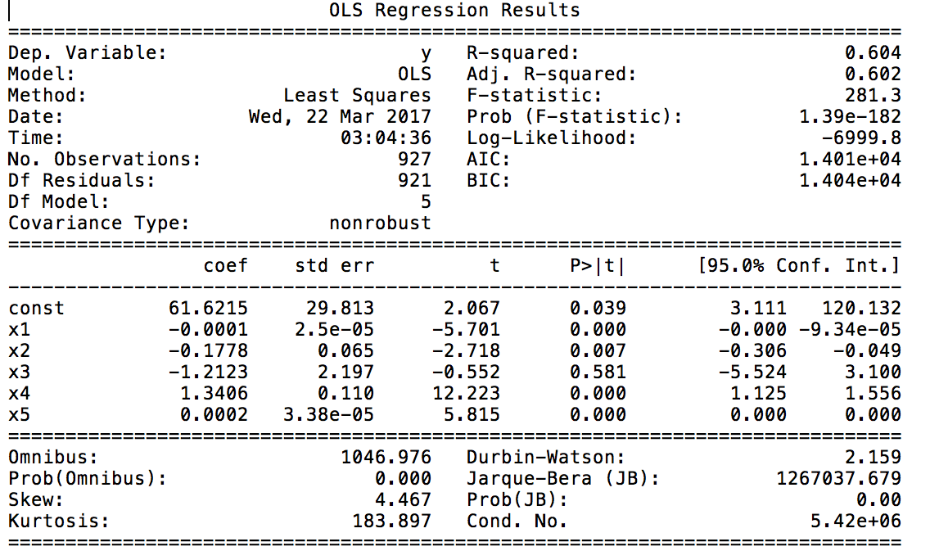

Report 5 : OLS Regression Results for nfl hashtag. R-squared accuracy can be observed as 0.604 indicating a decent fit to the model for this hashtag.

1. #patriots

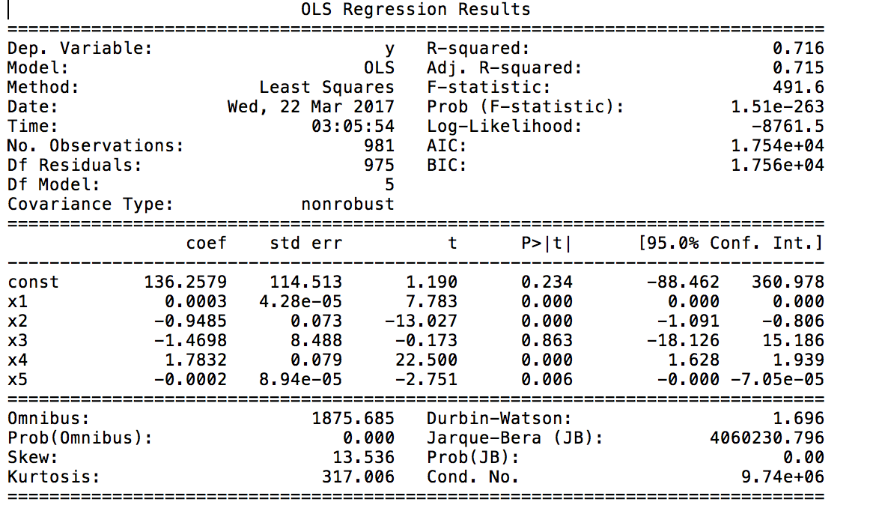

Report 6 : OLS Regression Results for patriots hashtag. R-squared accuracy can be observed as 0.716 indicating a good fit to the model for this hashtag.

**The results obtained for each hashtag shown above are summarized below:**

|  |  |
| --- | --- |
| Hashtag | Accuracy value |
| #gohawks | 48.8329 |
| #superbowl | 74.2456 |
| #gopatriots | 66.4003 |
| #sb49 | 82.0842 |
| #nfl | 60.4277 |
| #patriots | 71.6007 |

Table 1 : Model accuracy for each hashtag

|  |  |  |  |  |  |
| --- | --- | --- | --- | --- | --- |
| Hashtag | Maximum followers count | Retweet count | Time | Tweet Count | Follower Count |
| #gohawks | 8.345 * 10-6 | 1.392 * 10-4 | 5.811 * 10-1 | 2.347 * 10-6 | 2.826 * 10-6 |
| #superbowl | 8.458 * 10-40 | 8.445 * 10-1 | 7.177 * 10-1 | 1.351 * 10-10 | 6.144 * 10-22 |
| #gopatriots | 1.155 * 10-7 | 1.127 * 10-1 | 8.666 * 10-1 | 1.433 *10-2 | 5.690 * 10-10 |
| #sb49 | 4.308 * 10-13 | 2.014 * 10-16 | 5.284 * 10-1 | 7.413 *10-78 | 4.600 * 10-5 |
| #nfl | 1.606 * 10-8 | 6.691 * 10-3 | 5.812 * 10-1 | 6.032 * 10-32 | 8.350 * 10-9 |
| #patriots | 1.806 * 10-14 | 7.023 * 10-36 | 8.625 * 10-1 | 1.257 * 10-90 | 6.057 * 10-3 |

Table 2 : p-values for model parameters

|  |  |  |  |  |  |
| --- | --- | --- | --- | --- | --- |
| Hashtag | Maximum followers count | Retweet count | Time | Tweet Count | Follower Count |
| #gohawks | 4.478 | -3.824 | 0.551 | 4.747 | -4.710 |
| #superbowl | -13.830 | 0.196 | -0.361 | 6.492 | 9.867 |
| #gopatriots | 5.357 | 1.587 | 0.167 | -2.455 | -6.290 |
| #sb49 | 7.416 | -8.471 | -0.630 | 21.904 | -4.106 |
| #nfl | -5.700 | -2.717 | -0.551 | 12.222 | 5.815 |
| #patriots | 7.782 | -13.026 | -0.173 | 22.499 | -2.750 |

Table 3 : t-values for model parameters

**Analysis of results:**

1. **Accuracy:**
   1. We have used R-squared accuracy as a parameter to analyze the fit to the data. Higher R-squared accuracy indicates a better fit of model to the data.
   2. It can be observed that model fits the data better for #sb49 and #superbowl with accuracies as 82% and 74.2%
2. **P-value and t-value**:
   1. T-value is used to statistically determine significance of a variable in the model. It is important to pick the significant features while designing the regression model. The larger the absolute value of t, less likely the value of parameter could be zero. Thus we would want to select features with higher t-value.
   2. Lesser the p-value, higher the probability of being important feature for the model. Thus we want to select features with lower p-value.
   3. Based on analysis of p-value and t-value, significant features for each hashtag are as follows:
      1. #gohawks : Tweet count, Maximum followers count
      2. #superbowl : Tweet count, Follower count
      3. #gopatriots : Maximum followers count, Retweet count
      4. #sb49 : Tweet count, Maximum followers count
      5. #nfl : Tweet count, Follower count
      6. #patriots : Tweet count, Maximum followers count
   4. It can be observed that Tweet count and Maximum followers count are important features across all hashtags

*Part 3:* *Regression Model With Extra Features*

In this problem, we had to add additional features to regression model and analyze the significant features which can be used for the model and accuracy obtained for the model. We have used 11 features which are as follows:

1. Total Favorite Count
2. Ranking Score
3. Impression Count
4. Number of tweets
5. Individual listed frequency
6. Individual mention frequency
7. Total follower count
8. Number of retweets
9. Number of long tweets
10. Time
11. Number of maximum followers

**#gohawks**

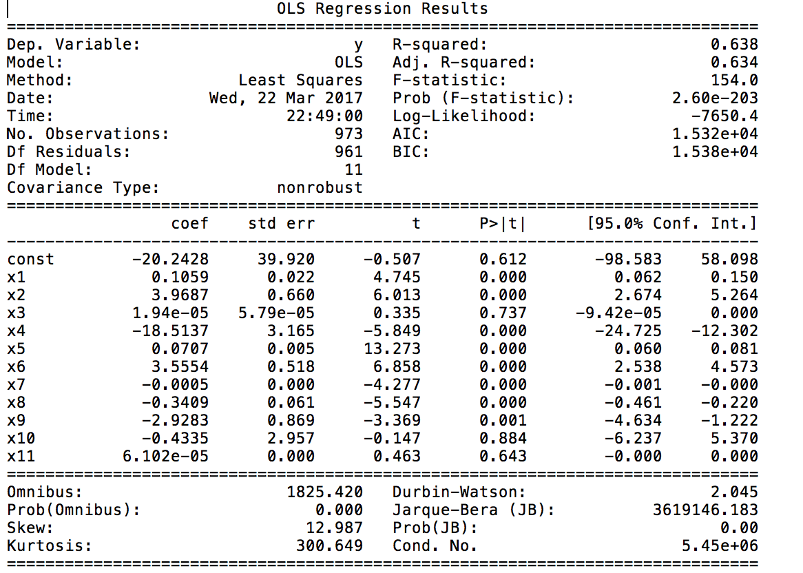

Based on p-value and t-value, we analyze the top features to be used. Based on this we train the model again. R-squared value give us the accuracy obtained with the freshly model trained with significant features analyzed in this step.

**Top 3 Features for #gohawks :**

1. Individual listed frequency
2. Individual mention frequency
3. Ranking Score

Scatter plot for these features are as follows:

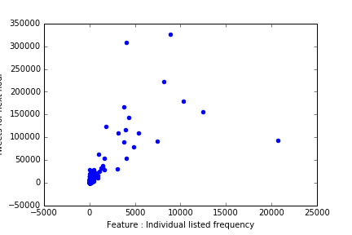

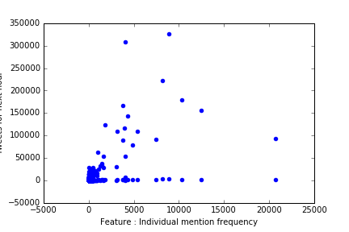

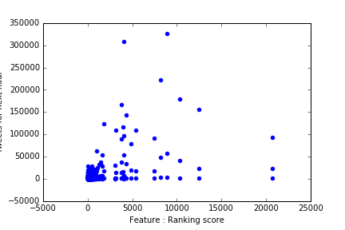

**#gopatriots**

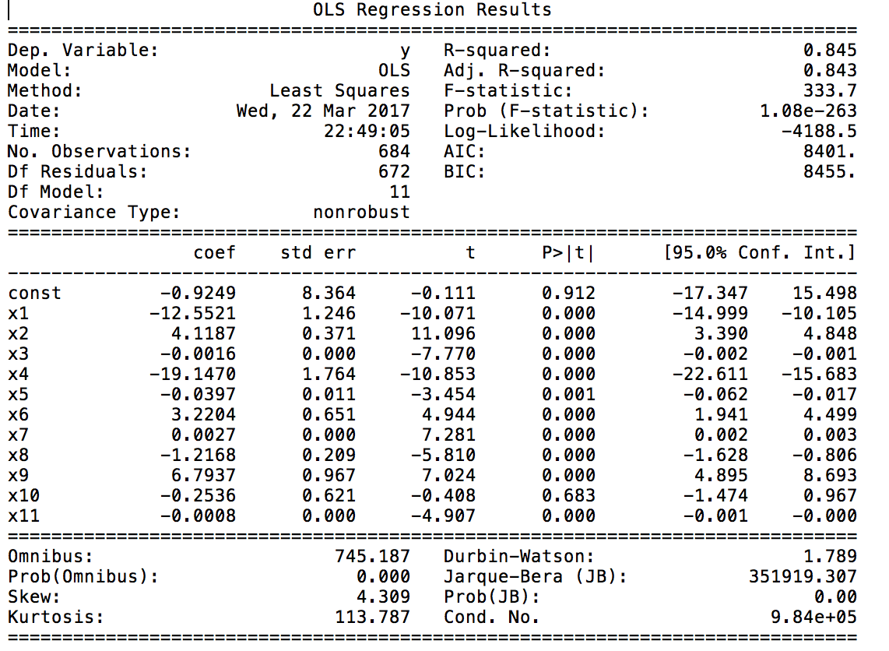

Based on p-value and t-value, we analyze the top features to be used. Based on this we train the model again. R-squared value give us the accuracy obtained with the freshly model trained with significant features analyzed in this step.

**Top 3 Features for #gopatriots**

1. Ranking Score
2. Number of long tweets
3. Impression count

Scatter plot for these features are as follows:

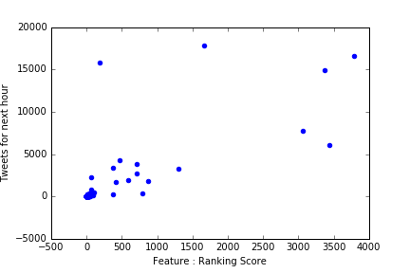

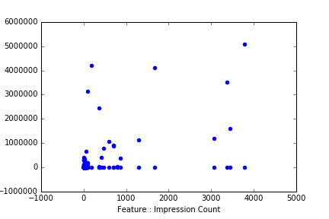

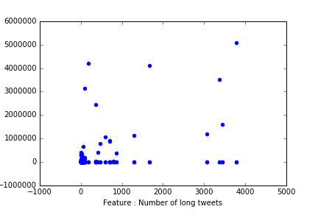

**#nfl**

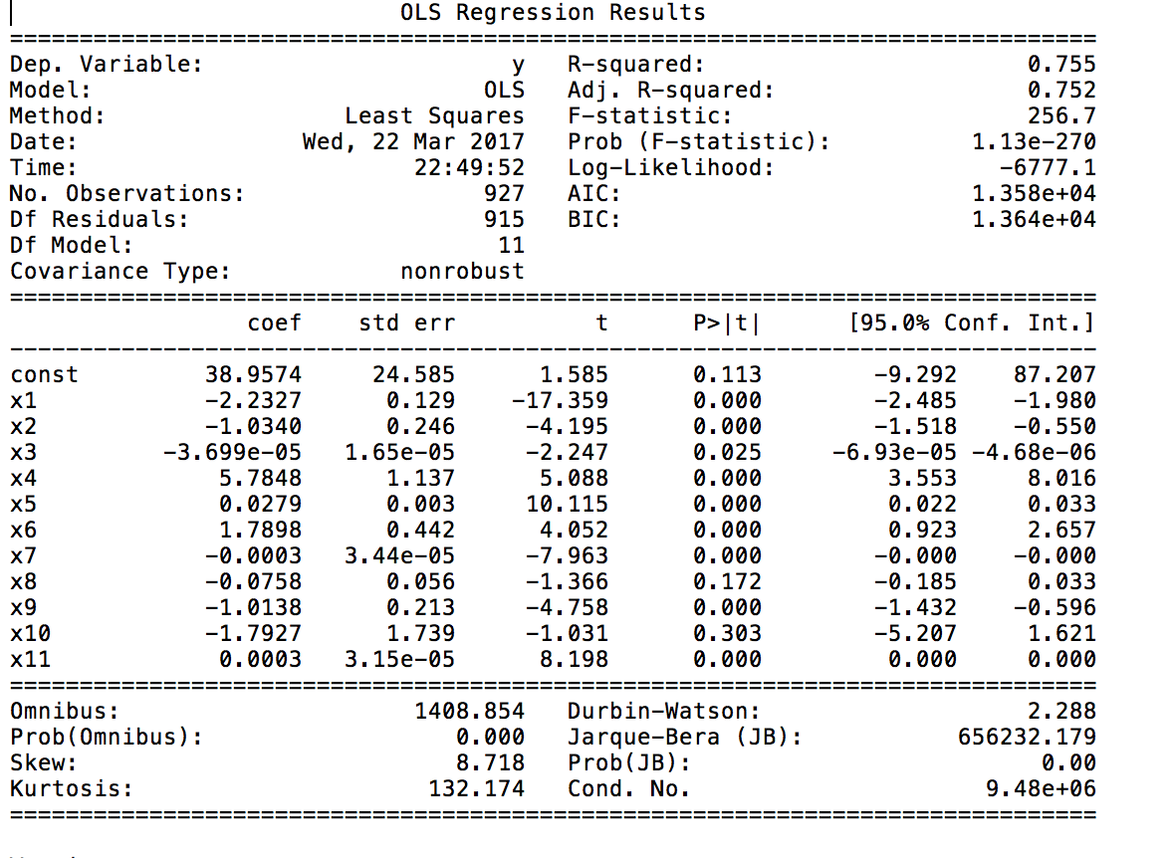

Based on p-value and t-value, we analyze the top features to be used. Based on this we train the model again. R-squared value give us the accuracy obtained with the freshly model trained with significant features analyzed in this step.

**Top 3 Features for #nfl**

1. Individual listed frequency
2. Number of maximum followers
3. Number of tweets

Scatter plot for these features are as follows:

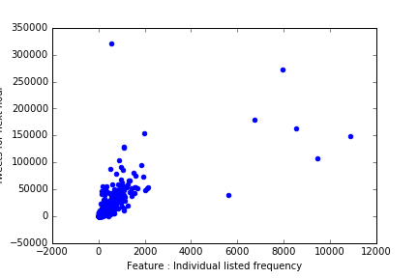

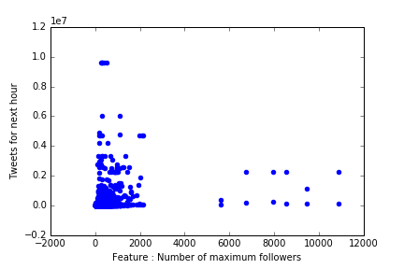

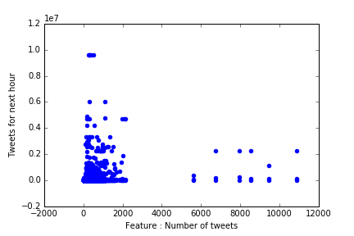

**#patriots**

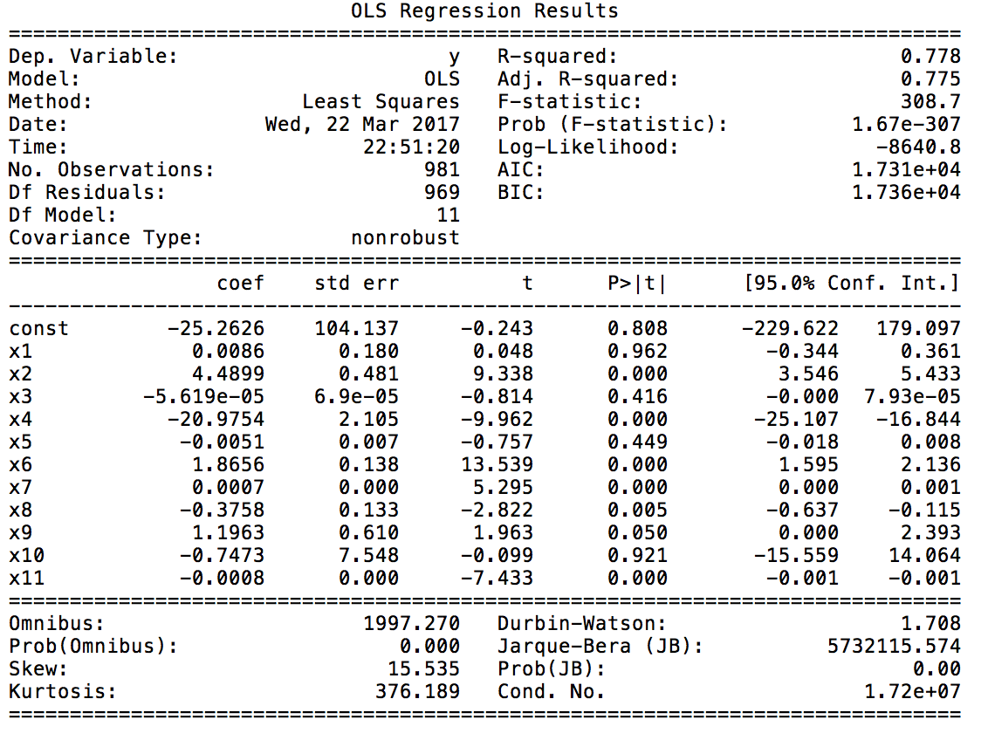

Based on p-value and t-value, we analyze the top features to be used. Based on this we train the model again. R-squared value give us the accuracy obtained with the freshly model trained with significant features analyzed in this step.

**Top 3 Features for #patriots**

1. Individual mention frequency
2. Ranking Score
3. Total follower count

Scatter plot for these features are as follows:

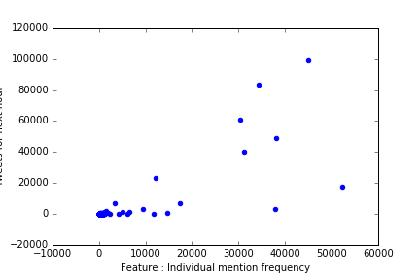

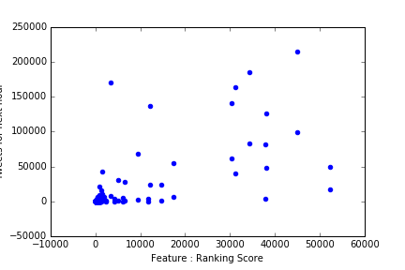

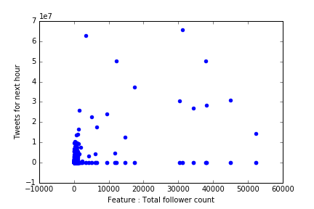

**#sb49**

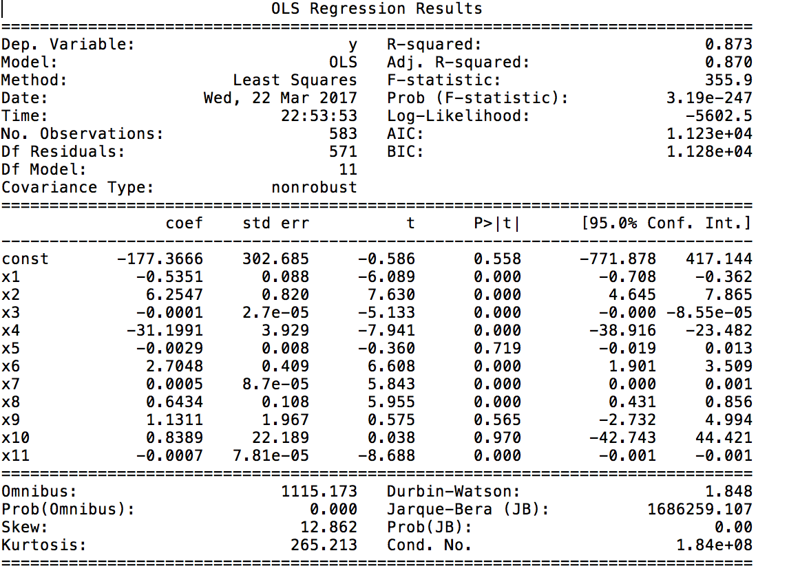

Based on p-value and t-value, we analyze the top features to be used. Based on this we train the model again. R-squared value give us the accuracy obtained with the freshly model trained with significant features analyzed in this step.

**Top 3 Features for #sb49**

1. Ranking score
2. Number of retweets
3. Total follower count

Scatter plot for these features are as follows:

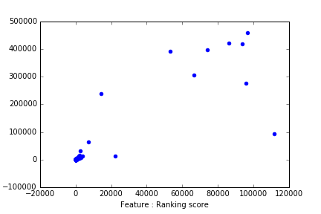

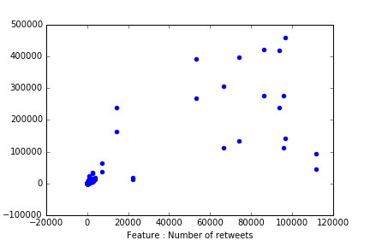

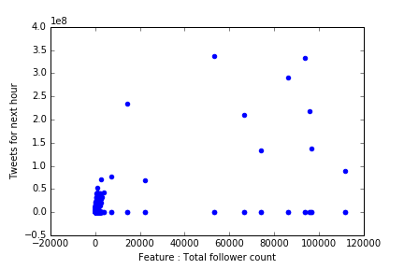

**#superbowl**

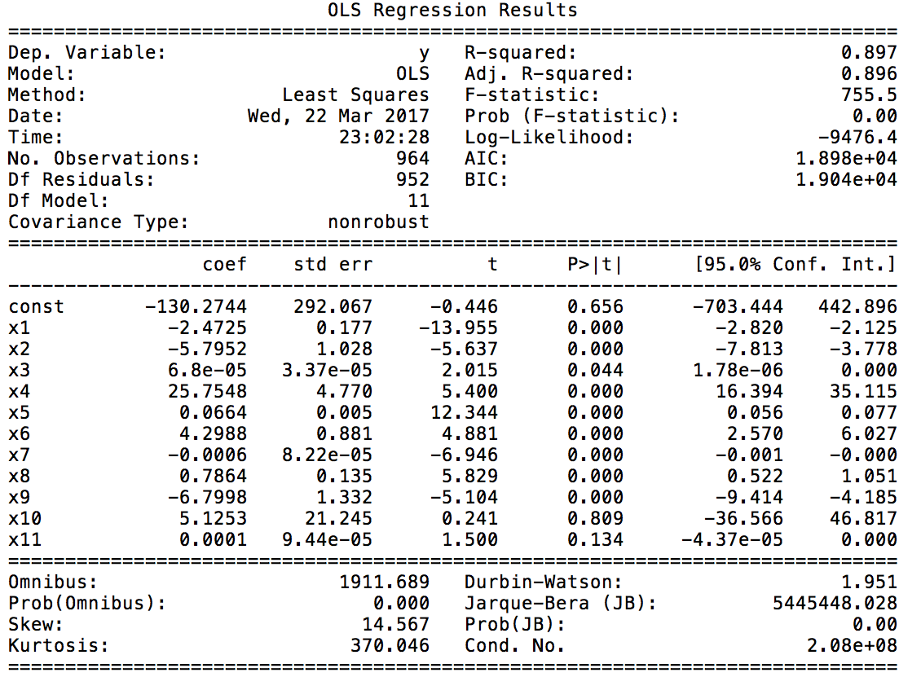

Based on p-value and t-value, we analyze the top features to be used. Based on this we train the model again. R-squared value give us the accuracy obtained with the freshly model trained with significant features analyzed in this step.

**Top 3 Features for #superbowl**

1. Individual listed frequency
2. Number of tweets
3. Number of retweets

Scatter plot for these features are as follows:

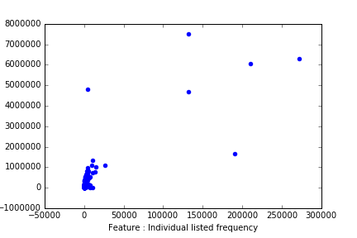

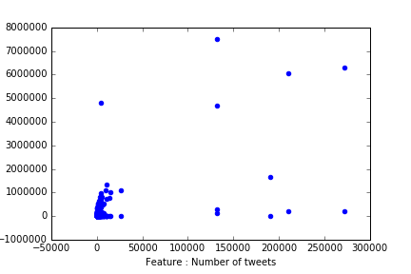

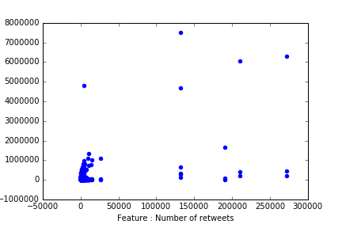

After obtaining the most significant features, model is trained again for each hashtag and following accuracies are obtained.

|  |  |
| --- | --- |
| Hashtag | Accuracy |
| #gohawks | 63.8 |
| #superbowl | 89.7 |
| #gopatriots | 84.5 |
| #sb49 | 87.3 |
| #nfl | 75.5 |
| #patriots | 77.8 |

*Part 4 (1) – Cross Validation*

In Part 4, we are required to use the 11 features obtained in Question-3 and to perform 10-fold Cross Validation across data.

The features are organized in the form of (features, predicant) pairs for each window. The feature data is split into 10 parts, such that 90% of our data will be used for fitting our model and 10% of the data will be used for testing the model.   
The process mentioned above, is performed 10 times on the feature data for each of our hastags. To evaluate the performance of the model, we use Prediction error for every fold.

Prediction error is calculated as = |Npredicted – Nreal|

**The accuracy results obtained across various hash-tags and over every fold given below**:

|  |  |  |  |  |  |  |
| --- | --- | --- | --- | --- | --- | --- |
| Fold No | #gopatriots | #gohawks | #nfl | #patriots | #sb49 | #superbowl |
| (1) | 5.497 | 3.624 | 5.8562 | 20.235 | 55.370 | 26.962 |
| (2) | 5.811 | 3.649 | 6.581 | 20.355 | 48.427 | 27.006 |
| (3) | 8.896 | 5.692 | 6.732 | 21.208 | 97.462 | 26.949 |
| (4) | 90.584 | 9.758 | 41.497 | 32.991 | 53.527 | 30.424 |
| (5) | 16.709 | 195.137 | 275.896 | 137.657 | 151.170 | 63.362 |
| (6) | 15.890 | 669.995 | 161.242 | 1033.888 | 300.923 | 1004.981 |
| (7) | 13.719 | 143.188 | 159.437 | 416.451 | 1726.575 | 231.682 |
| (8) | 12.524 | 151.169 | 349.7592 | 362.720 | 9300.742 | 904.430 |
| (9) | 289.840 | 828.921 | 780.542 | 3553.646 | 938.063 | 11322.880 |
| (10) | 5.756 | 8.919 | 300.279 | 108.647 | 278.735 | 708.964 |
| Average Error | 46.523 | 202.005 | 208.782 | 570.780 | 1295.099 | 1434.764 |

Table 4 : Average Error of 10 Fold Cross Validation

**Observation:**

* We can see that there is a relationship between the number of tweets for a hash-tag and the average error of cross validation. Greater the number of tweets leads to a higher absolute average error for the hash-tag.
* In particular, it is seen that for each hash-tag the error of one of the cross-validation fold is too high due to the uneven distribution of the data-set. A fold might consider a split wherein the test-data has all high values for the class (tweets during the time of the SuperBowl) and training-data has all low values for the class (tweets before and after the SuperBowl), hence producing a high error value for that fold.

*Part 4 (2) - Cross Validation with Time Periods*

The second part of Question-4 deals with analysis of regression models created for different time-periods during the SuperBowl. Three different time-periods were considered to create the regression models,

1. Before Feb. 1, 8:00 a.m. [when the hashtags haven’t become very active]
2. Between Feb. 1, 8:00 a.m. and 8:00 p.m. [active period]
3. After Feb. 1, 8:00 p.m. [after they pass their high-activity time]

Each tweet was segregated based on the time it was posted and split into windows of one-hour. The models were tested using 10-fold Cross Validation and the average errors for all folds obtained were as follows:

|  |  |  |  |
| --- | --- | --- | --- |
| HashTag | Period 1 | Period 2 | Period 3 |
| #gohawks | 200.038 | 5391.083 | 3619.449 |
| #gopatriots | 15.037 | 5511.565 | 3.407 |
| #nfl | 129.083 | 6274.101 | 320.641 |
| #patriots | 193.210 | 35029.398 | 119.486 |
| #sb49 | 99.697 | 89845.155 | 233.074 |
| #superbowl | 242.084 | 894816.135 | 456.501 |

Table 5 : Average Error of 10 Fold Cross Validation for each Time Period

**Observation**:

* The error seems to be extremely high for period 2. The reason can be that it is extremely difficult to achieve high accuracy using 12 training points. To deal with this problem we could use sliding windows to increase the number of data points

*Part 5 - Testing Data*

In this part, we test the models trained by us in part 4 and try to predict the values for the next hour.

The testing data was downloaded and for each file in the testing data features were collected using methods employed in the previous questions. There were 10 files in all, each of them corresponding to one of the three time periods. However, unlike before, the files had a mixture of all hashtags. But the models we had trained earlier were specific to a specific hashtag. So, we found the most dominant hashtag in each of the ten files. The dominant hashtags were:

|  |  |  |  |
| --- | --- | --- | --- |
| Test File | | Model Used | Dominant HashTag |
| Sample1_period1 | Superbowl model for period1 | | #superbowl |
| Sample2_period2 | Superbowl model for period2 | | #superbowl |
| Sample3_period3 | Superbowl model for period3 | | #superbowl |
| Sample4_period1 | Nfl model for period 1 | | #nfl |
| Sample5_period1 | Nfl model for period 1 | | #nfl |
| Sample6_period2 | Superbowl model for period 2 | | #superbowl |
| Sample7_period3 | Nfl model for period 3 | | #nfl |
| Sample8_period1 | Nfl model for period 1 | | #nfl |
| Sample9_period2 | Superbowl model for period2 | | #superbowl |
| Sample10_period3 | Nfl model for period 3 | | #nfl |

*Table 6 : Dominant hashtag for the 10 testing files*

For all tags the data for 6 hours had been provided. We had to predict the value for next hour. So given the data from hour 1 to hour 6, we had to predict from hour 2 to hour 7.

|  |  |  |  |  |  |  |  |  |  |  |  |  |  |  |  |
| --- | --- | --- | --- | --- | --- | --- | --- | --- | --- | --- | --- | --- | --- | --- | --- |
| Test File | | Hour 2 | | Hour 3 | | Hour 4 | | Hour 5 | | Hour 6 | | Hour 7 | | Error | |
| Sample1_period1 | 115.21 | | 50.32 | | 176.80 | | 265.35 | | 461.99 | | 652.02 | | 213.771 | |
| Sample2_period2 | 614779.9 | | 68409.37 | | 503125 | | 412958 | | 3331221 | | 1806319 | | 1124174.596 | |
| Sample3_period3 | 510.03 | | 723.36 | | 715.78 | | 628.06 | | 643.21 | | 651.30 | | 197.783 | |
| Sample4_period1 | 1375.94 | | 562.02 | | 221.95 | | 342.30 | | 134.77 | | 86.02 | | 332.014 | |
| Sample5_period1 | 491.76 | | 542.83 | | 397.72 | | 308.70 | | 448.62 | | 263.73 | | 253.39 | |
| Sample6_period2 | 11855.12 | | 108855390 | | 66174686 | | 5643991.7 | | 4233358.1 | | 347051.3 | | 35124214.656 | |
| Sample7_period3 | 86.61 | | 69.31 | | 60.58 | | 51.63 | | 54.21 | | 68.96 | | 31.343 | |
| Sample8_period1 | NA | | 57647.17 | | 47250.27 | | 58692.12 | | 72259.96 | | 101448.2 | | 67423.561 | |
| Sample9_period2 | 907629 | | 936522 | | 790894 | | 750649 | | 1019 | | 895972 | | 715378.320 | |
| Sample10_period3 | 43.57 | | 41.00 | | 38.55 | | 36.31 | | 35.28 | | 32.25 | | 25.278 | |

Table 7: Predicted Value for 7th Hour using Regression Model

**Error = Actual – Predicted Vale.**Note : hour 7 is skipped over here as the data for hour 7 was not available

*Part 6 – Fan Base Prediction*

In this part, we train a classifier to predict the location of the author, given only the textual context of the tweet. Because often the textual context reveals some information about the author. Recognizing that supporting a sport team has a lot to do with the user location, so, we try to use the textual content of the tweet posted by a user to predict her location.

For this part, we consider all the tweets including #superbowl, by users whose location has been specified as either Washington state or Massachusetts state. [we consider the tweets that include the following substrings in the location field: Seattle, Washington Washington WA Seattle, WA Kirkland, Washington]

We train different classifiers and evaluate their performance. The classifiers used are:

1. Multinomial Naive Bayes
2. Logistic Regression
3. Linear SVM

The following steps are followed:

1. Collect tweets from superbowl
2. Filter out tweets by appropriate location data
3. Create target labels (0: MA 1: WA ) and Balance the datasets
4. Vectorize the tweets:

Since there are lot of common words, the data needs to be preprocessed. For this, first the punctuations are removed, followed by the common stop words. We then find which words share the same stem so that they can be counted together while finding their TF-IDF vectors. To do the latter, we used a SnowBall stemmer (nlkt) to achieve this.

Once the data has been pre-processed, we move on to finding the TF-IDF vector for each term. For this we convert the document into a set of numerical features. This is done using CountVectorizer

1. Truncate twitter data to 50 features using Truncated SVD
2. Perform Feature Scaling for Certain Algorithms Require Nonnegative Values
3. Perform 5-Fold CV to fit different models. The results are given below. The best accuracy was obtained for Linear SVM as 0.8117. The performance for Logistic Regression was comparable.

**Multinomial Naive Bayes**

|  |  |
| --- | --- |
| Parameter | Value |
| Average CV- Accuracy | 0.7370 |

|  |  |  |  |  |
| --- | --- | --- | --- | --- |
|  | Precision | Recall | F1-Score | Support |
| 0 (MA) | 0.70 | 0.85 | 0.77 | 3357 |
| 1 (WA) | 0.81 | 0.63 | 0.71 | 3351 |
| Avg/Total | 0.75 | 0.74 | 0.74 | 6708 |

|  |  |
| --- | --- |
| Confusion Matrix | |
| 2862 | 495 |
| 1251 | 2100 |



Figure 7: Performance evaluation for Multinomial Naïve Bayes

**Logistic Regression:**

|  |  |
| --- | --- |
| Parameter | Value |
| Average CV- Accuracy | 0.8092 |

|  |  |  |  |  |
| --- | --- | --- | --- | --- |
|  | Precision | Recall | F1-Score | Support |
| 0 (MA) | 0.75 | 0.94 | 0.84 | 3357 |
| 1 (WA) | 0.92 | 0.69 | 0.79 | 3351 |
| Avg/Total | 0.84 | 0.81 | 0.81 | 6708 |

|  |  |
| --- | --- |
| Confusion Matrix | |
| 3161 | 196 |
| 1052 | 2299 |



Figure 8: Performance evaluation for Logistic Regression

**Linear SVM:**

|  |  |
| --- | --- |
| Parameter | Value |
| Average CV- Accuracy | 0. 8117 |

|  |  |  |  |  |
| --- | --- | --- | --- | --- |
|  | Precision | Recall | F1-Score | Support |
| 0 (MA) | 0.75 | 0.95 | 0.84 | 3357 |
| 1 (WA) | 0.93 | 0.68 | 0.79 | 3351 |
| Avg/Total | 0.84 | 0.82 | 0.81 | 6708 |

|  |  |
| --- | --- |
| Confusion Matrix | |
| 3179 | 178 |
| 1059 | 2292 |



Figure 9: Performance evaluation for Linear SVM

Part 7 - Twitter Ad Week (Event Sequencing)

The SuperBowl event has a huge fan following. It is one of the most popular and widely watched events in the United States. Which has an impact on the activities on Twitter. It is an extremely important platform for some very high profile advertisements given its huge fan base and outreach. We propose an **event sequencing** and analytics problem. We aim to recreate the flow of events that happened at the Superbowl using the tweets. At the same time **analyze how the popularity of different advertisements varied during the timeline of the superbowl**. Through that we aim to project a **brand comparison**, which shows which brands gathered the most attention and at which point of time in the superbowl. Which depicts how the event impacted these brands.

The procedure for the same has been documented below:  
We first get all the tweet text for a hash tag using the concept of one hour windows. The data is then preprocessed to get rid of the special characters and the stop words. The keywords are then tokenized into two groups. Which is hash tags and non-hash tags data. The data is classified into different advertisement groups. Some brands that we will be considering in our analysis are :

1. T-mobile
2. Budweiser
3. Snicker
4. McDonald’s
5. Coca Cola
6. Dove’s Mencare

For brands which have two words in their name. We count them using bigrams where the commonly occurring pairs are put into a counter which puts together key word pairs for every hour. The result of this classification is the hourly count of occurance of every advertisement.   
We then show the even flow for SuperBowl by dividing the flow into four topics of

1. Team Chatters
2. Touchdowns or goals
3. Advertisements
4. Celebrities

Each topic is analyzed for every hour. Which means it’s based on one-hour window. We then use the Vincent library in Python which generates a JSON file with the indexes and data for every topic. Then, D3 is used for the final visualization.